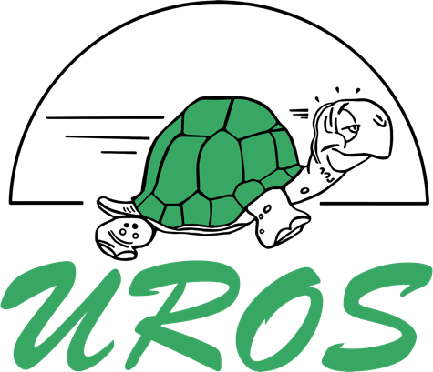 | Urosalumnus

Membership form Urosalumnus

Name:
Address:
Postcode + city
Phone number:
E-mail address:
IBAN + BIC:
First season I became a member of MSAV Uros:
Last season I was member of MSAV Uros:

I want to receive the ‘’Steddie’’ association book four times per year.
I want to receive the ‘’actie’’ and competition mail every month via e-mail.

I hereby declare my wish to become a Urosalumnus of MSAV Uros until further notice. I authorize MSAV Uros to collect the owed membership fee of €20,- from my bank account once a year.

Place: |  | Signature:
Date:
If your address changes, let the secretary of MSAV Uros know via bestuur@uros.nl. Termination of the Urosalumnus-membership has to be done before the first of September at the secretary. The contribution counts for one academic year, from September until September. The contribution will be withdrawn in September, except when the application is received after September. In that case, the contribution will be withdrawn immedietly after the application. Do you not want to receive the Steddie anymore? Let it know before the first of September.
Processing personal data of alumni members

Personal data of association members are processed by MSAV Uros for the following purposes:
- Administrative purposes;
- Communication purposes;
- Implementing the membership agreement.

The foundation for these personal data is:
- Membership agreement;
- Registration newsletter.

For the purpose(s) stated above, MSAV Uros can ask for the following personal data:
- Name;
- Address;
- City;
- Phone number;
- E-mail address;
- IBAN-number;
- Language of speak;
- Date of registration MSAV Uros;
- Date of registration Alumni MSAV Uros.

I hereby declare my wish to become a Urosalumnus of MSAV Uros until further notice. I authorize MSAV Uros to save and use my information mentioned above.

Signature:

